

ExDoc 3.0
Administration Manual for Web Contract Management

Last revision: 2018-01-18

Contents
Introduction 4
Concepts 5
Logging in 6
Overview of Administration for ExDoc 7
Understanding ExDoc Security 8

User Roles 8
Viewer 8
User 8
SuperUser 8
Admin 8

Confidentiality Levels 8

Organisational Units 9

Projects 9

Scanning Documents & Scan path 10
Administration/Users 11
Adding a New User 12
First Name 12
Last Name 12
Username 12
Password 12
Confirm Password 12
E-mail 12
User Roles 13
Confid Level 13
Active Flag 12
path 13
Move this users Documents and Reminders to 13
Organisation Access 13
Project 13
Edit a User 14
Administration/Organisations 15
Administration/Projects 16
New Project 16
Edit Project 16
Delete Project 16
Administration/External Parties 17
Administration/Counterpart Types 18
Administration/Document Types 19
Add New 19
Rename 19
Delete 19
Add New Extra Field 19
Rename Extra Field 19
Delete Extra Field 19
Up/Down 19
Administration/Archive Location 20
Add New 20
Rename 20
Delete 20
Administration/System Information 21
Database Version 21
MaxRowsInSearchResult 21
NumberOfDocumentsReg 21
Server Version 21
path 21
ExDoc Reminder Sender 22
Application Options 23

Introduction
The administration of original agreements can become a time consuming chore for any organisation. When you start with a small number of agreements things are simple, but as the number of agreements increase, you will start to wish that there was a better way to do this.
ExDoc is a web based software application that stores everything in a popular database. It is a tool for controlling paper contracts with signatures and other kinds of agreements. By scanning the original agreement, you get an electronic copy that can be stored securely together with additional relevant information, and managed by ExDoc for the lifespan of the agreement.
As the agreement goes through different stages, ExDoc can update you via e-mail, reminding you to take the appropriate action.
Contracts and agreements are always of a confidential nature, so a comprehensive security system is built into ExDoc, securing the information from unauthorized access. Furthermore, ExDoc includes an advanced audit trail system that monitors how, when and by whom a specific document is accessed.
This guide will explain the basic concepts and how to Administer ExDoc.

Concepts
Moving from manual handling of agreements to ExDoc involves a few important steps. If the agreement is on paper, it must first be made ‘electronic’ by scanning. The scan will result in a file such as an Adobe Reader Portable Document Format file (PDF). The original source document can also be a computer file such as a Word document, Excel worksheet, or a program originated PDF file with digital signatures. Once in electronic form, we can start to work in ExDoc.
The first step is to register the electronic document in ExDoc. As well as loading the image into the database, this involves associating relevant information with the document. This type of information is referred to as ‘meta-data’. What type of data this should be, can be answered by asking what do I really need to know about this agreement, to be able to manage it efficiently? Is the agreement signed with an external party or is the counterpart internal to the company or group? What type of agreement is it? Is it a rental contractor an employee agreement? Which organisation in the company is the agreement linked to? And perhaps, most importantly, when is the agreement due to be renegotiated?
In this way, all the data you need, will be stored together with the document ready to be accessed, searched and edited using a standard Internet browser.
One of the key features of ExDoc is that a reminder e-mail can be automatically sent to the documents owner, 1 or 2 months before the due date. For most agreements, once the document is properly registered, you can ‘leave it be’ until the reminder alerts you to take action.
Does this mean that we can now tear up all the paper agreements once they are registered in ExDoc? Probably not, but it does mean that you can store them in a safe place off-site.
Putting ExDoc into effect has an initial period, where the many existing contracts and agreements are scanned and registered. After this you will use ExDoc by adding new agreements, act upon reminder messages and inactivate expired agreements.
In ExDoc and in this manual, contracts and agreements are referred to as ‘documents’. Any important information can be saved as a document in ExDoc, for example company incorporation papers.
You do not delete documents from ExDoc; instead you set the document ‘Status’ to inactive. Then you can still refer to them later.
Before you start working with ExDoc, you should familiarise yourself with the general concepts of an agreement management system and also the specific ways in which ExDoc works.

Logging in
To use ExDoc you need a Windows PC with Microsoft Internet Explorer (IE) version 11.0 or latest versions of Edge or Chrome. You should also have been given the ExDoc URL and an account to use.
The URL could look something like http://intranet/exdoc. Open Internet Explorer and type in the ExDoc URL in the address field. After pressing Enter you will see the logon screen of ExDoc:
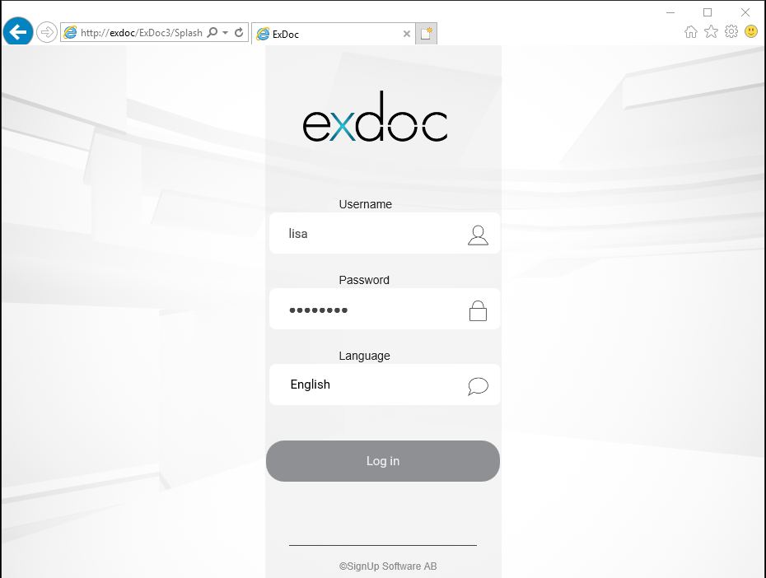

Now you can type in your Username and Password and click the ‘Log in’ button. Your initial password will be “password” (without the quotes) at first login. You should change this to a personal password in ExDoc. You can see how to do this under Error! Reference source not found.. In the screen above, Lisa Doksson logs in with her username ‘lisa’ and fills in her password. The password is not shown in clear text, but as a string of asterisks.

Overview of Administration for ExDoc
Only users with the role ‘Admin’ can access this tab. All administration functions are here.
Click on the Administration tab to see the available of sub-sections.
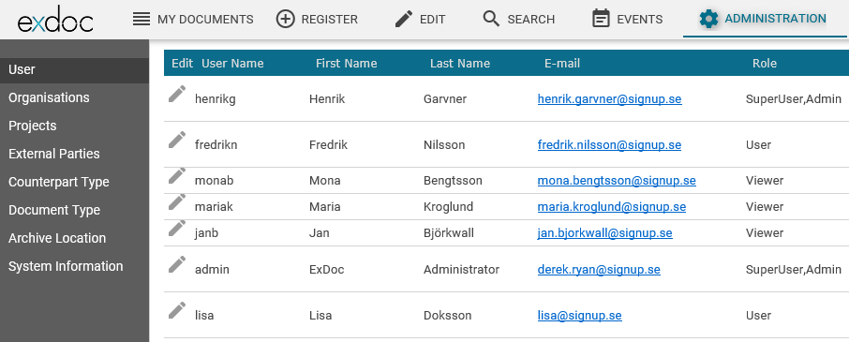
Functions under administration are accessed by clicking the named tab on the left side.
- User – Add new users, change access rights, move documents to a new user and make inactive.
- Organisations – A hierarchical dimension. Here you can add a new root or member organisation, move documents from one unit to another and delete an unused unit.
- Projects – A flat, free choice dimension. Here a customer selects a preferred additional category to apply to some or all documents. Most often called ‘Project’ but could be ‘Cost Centre’ or another choice determined during initial setup.
- External Parties – People inside or outside the organisation who are not users of ExDoc but are associated with documents for contact purposes.
- Counterpart Type – Category assigned to documents to indicate the type of organisation that has been contracted with. Here you can add new or remove types.
- Document Type – During initial setup, number of document types will have been defined. Here you can add more, rename or remove them. You can also add extra fields specific to each document type.
- Archive Location – This can be used to maintain a list of the physical locations where the original paper agreement has been stored. Only values entered here can be applied when registering the document.
It is also possible to rename this drop down list and use it for something else.
- System Information – Mainly used to add private storage paths for some users.

Before adding Users or changing Organisations it is important to read the following section on how access is controlled in ExDoc.

Understanding ExDoc Security
Each User in ExDoc is associated with:
- One or more Roles
- One Confidentiality level
- One or more Organisational units
- One or more Projects
- Optionally, one Scan Path

Each Document in ExDoc is associated with:
- One Confidentiality Level
- One Document type
- One Organisational Unit
- One or more Projects

User Roles
Each ExDoc user is assigned one or more User Roles. These tailor a user’s access to the different parts of ExDoc depending on their needs and responsibilities in the company. The available roles are:
Role | Properties
Viewer | This role limits the user to only viewing document images and metadata. No information can be amended.
User | Someone who has a greater responsibility in the company. This role gives the ability to register and edit documents.
SuperUser | Same as ‘User’, but with the added ability to view Events.
Admin | This role is used for adding users and changing system parameters etc. This role cannot by itself, view or edit any documents.

!
Note: A user can be given combinations of roles. For example, the role SuperUser is often combined with the role Admin. This gives access to all parts of ExDoc.
The only roles that can register documents are User and SuperUser.
If you have SuperUser you do not also need User.

Confidentiality Levels
The confidentiality levels between user and document are compared to see if the user can access the document. The confidentiality/restriction relation is as follows.
User/document confidentiality level | Restriction level
1. Open | None
2. Confidential | Medium
3. Strictly confidential | High

A user associated with the level ‘Open’ can only access documents associated with a level of Open, and not documents associated with the levels Confidential or Strictly Confidential.

A user associated with the level ‘Confidential’ can access documents associated with a level of Open and Confidential but not documents associated with the level Strictly Confidential.

A user associated with the level ‘Strictly Confidential’ can access documents associated with all levels of confidentiality.

!
Note:
- A user with any level of confidentiality can register documents and give the document any level of confidentiality. However once the document is registered, that document might not be accessible to the user who registered it. That is, ExDoc security goes into effect after the document is registered.

- A user added as an Owner of a document, will have access to the document regardless of any level of confidentiality or other association set. That is, document ownership overrides all other settings. These documents show up under My Documents and are also searchable for the user.

Organisational Units
The hierarchical dimension in ExDoc is normally set up at initial configuration as your organisational structure. This does not have to correspond directly to your group or companywide organisation chart, which can be detailed and fairly complex. In ExDoc, you only need a simple structure that meets the need to categorise the various agreements, making them easy to search and list for reports and to control user access.

As seen under “Registering Documents” in the User Manual, each agreement should be associated with a single organisational unit.

Normally, when a user is added to ExDoc, the user account will get associated with one or more organisational units. Then he will be able to retrieve all those documents which had the same organisation associated when registered.

Projects
A second free dimension is available in ExDoc. This dimension is ‘flat’, meaning that it does not have a tree structure with ‘members’ like a hierarchy but is a single list of categories or classifications. The list could be a list of cost centres or for a matrix organisation, the different functional divisions which go across organisations. In ExDoc, this is most commonly used to assign agreements to a project. In ExDoc, there is also a configuration option, which should be set from the start, to allow the assignment of more then one value from the list.

The primary function of ‘Projects’ is to allow another means of categorising, and aid the search for agreements. However it can also be used to grant document access for a particular user across organisational structures to a set of documents. For example, an IT manager is not interested in general office contracts, but would like to see all agreements relating to Computers and Telecoms signed outside of his own department. In a geographically spread company, this can often happen. So, if the local purchasing manager, as well choosing his own unit also assigns the contract to a project called ‘Data & Telecoms’ then the IT Manager, when he is added to ExDoc can be associated with that project and will not need to be associated with the many organisations.

Scanning Documents & Scan path
Firstly, an overview of the initial scanning process:

Recieve original document with signatures.

Scan the original to make an image file.
Use an office network copier/printer/scanner that has been configured to save the file to a the shared folder on the file server.
If the document is confidential you will probably use a personal scanner which will save the file to a local folder. This should then be moved to the shared folder.

This network folder is usually called ‘ScannedImages’ but is something that is decided during installation as is the server that holds it. Access should be resticted to ExDoc users.

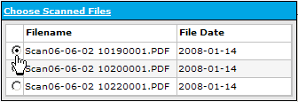
The web application ExDoc is setup to list the files in this same folder. Under ‘Registration’ in ‘Choose Scanned Files’ when you click on the radio button by the file name, the file will be loaded and the image displayed.
The User now follows the procedure for registering a document.

When the user clicks on ‘Register’ the application will save the image and the meta-data which includes all access limitations into the ExDoc database in a SQL Server. The image is also encrypted.

Once the document is registered, the scanned image is not needed and ExDoc usually deletes it from the shared folder so that it will no longer be listed in ‘Choose Scanned Files’. However an alternate setup can move that file to another secure folder on the server as a secondary backup.

You may have noted from the above schematic, that the document is most vulnerable to unsanctioned access in the time between scanning and beginning registration. For example, when an employee agreement should be stored in ExDoc and has been scanned to the shared folder, before the registration has started, there would be nothing to stop a person that registers, for example rental contracts, to view and read the employee agreement in that folder. Of course, this is not what we want.
Note: once the registration procedure has started, the file is locked for other ExDoc users. This ensures that the document cannot be registered twice and that no one else can view it. It would only become available again if the registration is cancelled or times out. It is best practice to register directly after scanning.
To overcome any potential risk, the documents can be scanned into different folders. A User who deals with highly confidential material can be associated with a private scan folder or ‘Scan Path’ to ‘Choose Scanned Files’. This way the trusted person within the HR department will be the only one able to see these files and to register these types of documents.
You will find more about how to set up the Scan paths in “Administration/System Information/path”

Administration/Users
To fully understand how to setup users you should first have read through the previous section called Understanding ExDoc Security.

When you click on the Administration tab, by default the page opens to show the User panel. If you change to another panel and want to return to Users, click on the User tab on the left.
This panel gives you the ability to add or change the settings for ExDoc User accounts. Each row in the grid represents a user.
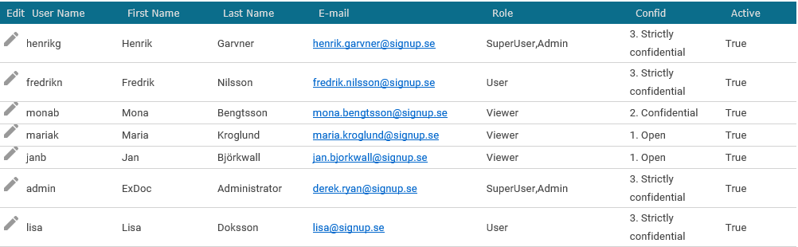

Click the pen icon under edit to make changes for that user. See “Edit Users” for more details.
Tip: Click the ‘Export’ button to create a spreadsheet of all the users.

Adding a New User
To add a new user to ExDoc click ‘Add User’ to see the details panel and fill in the fields according to the table below.
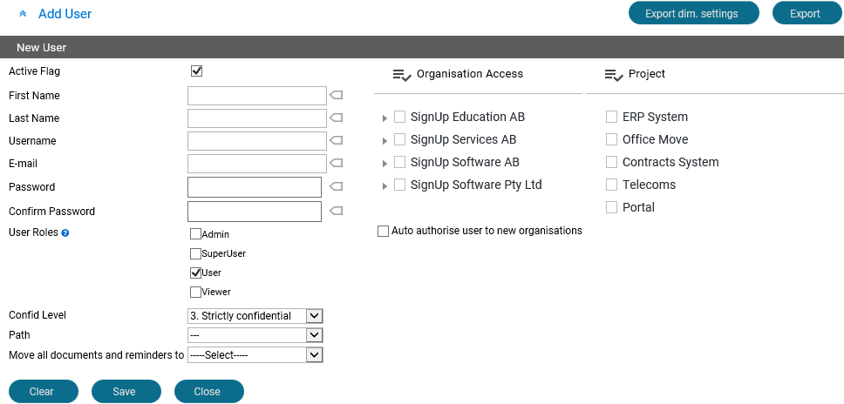

Active Flag | By default, when you add a new user the Active Flag is set to Active. Leave it that way unless there will be a delay before they start to use ExDoc.
First Name | Personal Name
Last Name | Surname or family name
Username | The user’s system login name. Often, it is easiest to make this the same as their Windows login id.  Note: If you are using integrated login you must add the Windows Active Directory domain name in front of the user name, e.g. domainname\lisa
Password | At least 6-characters long. You should send this password together with the URL to ExDoc by email to the new user and ask them to use ‘My Settings’ to change to a personal password as soon as possible.  Note: If you are using integrated login this password is not used but you must enter something in order to save.
Confirm Password | Must be the same value as above even if not used.
E-mail | The users e-mail address, e.g. lisa.doksson@company.com

User Roles | Click in the check box to assign one or more roles. You can click on to get a list of the function tabs for each role. See also “User Roles” for an overview.  Tip: For all tabs assign ‘Admin’ + ‘SuperUser’.
Confid Level | Short for Confidentiality Level. Select one of 3 levels. The level ‘3. Strictly confidential’ is the highest security level.  See also Confidentiality Levels for an overview.
Path | This is the path referred to in “  !  Scanning Documents & Scan path” It points to the shared folder with images to be registered. The default is indicated by ‘---‘, meaning it will use the common share usually called ‘ScannedImages’. If the user needs a private folder, this must first be added in “Administration/System Information/path”, see there for full details. Then you can use the dropdown list to assign that folder to the user who will see it in Register/Choose Scanned Image.  Note: A sub-folder with the same name must be created under the ‘ScannedImages’ share on the file server and given the correct access rights.
Move this users Documents and Reminders to | This field has no effect when adding a new user. Ignore it.  It is used before a user is made inactive to move any documents they own to another user.
Organisation Access | For users to be ‘allowed’ to find documents in ‘Search’ select one or more units that are relevant to their responsibilities. For some ‘Super Users’ or Administrators of ExDoc you may want to give access to all documents. A quick way to do that is to click the ‘Check/Uncheck all folders’ check box.  In a similar way, if you want give a department head access to all member folders, click on the check box alongside the top level of each branch and then click the check box for ‘Check/Uncheck all sub-folders of selected folder’  Tip: Check “Auto authorise…” to grant access to any new organisation folders that are added later.
Project | Select one or more Projects to grant access to all documents that are assigned to that project. You can check all by clicking on ‘Check/Uncheck all’.  !  Note: A user granted access to a Project will be able to see the documents even if he does not have access to its organisation.

When you are finished, click the ‘Save’ button to save the new user in ExDoc.
Now you can send the user the ExDoc web address on your internal network (URL) and their credentials for using ExDoc. Perhaps, also send an invitation to the next “Introduction to Using ExDoc for Contract Management” class.

Edit a User
Click the pen icon for a row in the grid under edit. The user information is displayed below grid.
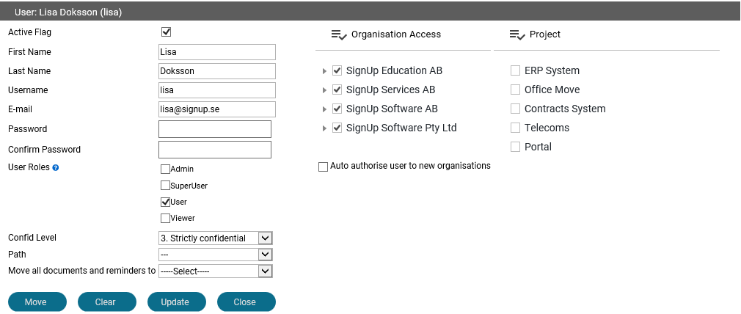

!
Note: You cannot delete a user in ExDoc. The reason for this is to keep their audit trail under ‘Events’ intact, unique and still available for future reference.
Instead, set the user to Inactive status with the ‘Active Flag’. An inactive user cannot log in to ExDoc even if the credentials are still valid. This is particularly useful if you need to bar a user in the period between giving notice and departure.
If that user owns any documents in the system, even as joint owner, then the system will block you from making them ‘Inactive’. You must use the ‘Move this users Documents and Reminders to’ function. Select the target user from the dropdown list and then click on ‘Move’

After you have made your changes, click the ‘Update’ button to commit them.

Administration/Organisations
Here you can add, rename and, if they have no documents, delete folders for Organisational units.
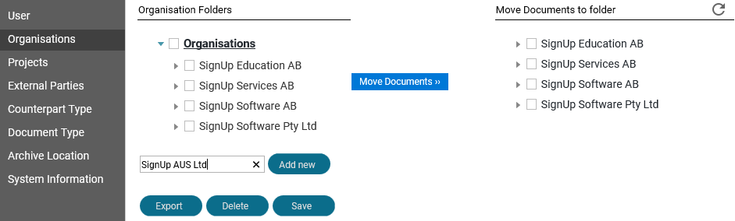

When re-organisations occur, changes can be made to your structure in ExDoc.
Add new | Check against the name at the level under which you want to make the new organisation. Against ‘Organisations’ for a new root level. Click on the sign to expand the structure. Then enter the name of the new unit in the ‘Add new’ field and click on ‘Add new’.  Note: Remember to give Users access to new folders.  !
Rename | If you want to rename a folder, double click it under Organisation Folders first. It will become “editable”. Change it to the new value, press TAB and then click ‘Save’.
Delete | To delete a folder, check it under Organisations first. Click ‘Delete’. A confirmation message will appear with the name of the folder that will be deleted. Click ‘Yes’ if it the correct name otherwise click ‘Cancel’. If there are any documents for that organisation and you get a warning;  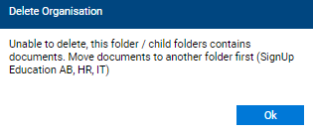  Then you must use ‘Move Documents’ first.
Move Documents | First select the source folder under Organisation Folders, then select the target under ‘Move Documents to folder’ and click ‘Move Documents’. A message will confirm the number moved.

Tip: Click the ’Export’ button to create a spreadsheet of all the organisations.

Administration/Projects
On this panel you can add, rename and, if they have not been assigned to users or documents, delete Projects.
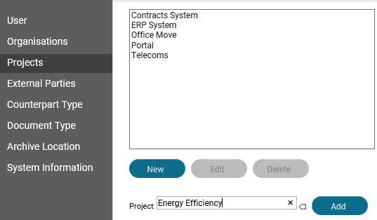

New Project | Click ‘New’ then click inside the ‘Project *’ text box and enter the name of your new project. Click on ‘Add’ to add the new project to the list.
Edit Project | Click on the name in the list and then click on ‘Edit’. The name will appear in the text box and you can change it to a new value. The ‘Add’ button will change to say ‘Update’ so click it to save back to the list.
Delete Project  You will not normally need to remove a project from ExDoc. You are more likely to rename it to add e.g. .../completed, then the information will still be available for reporting.  In this case, if you really want to delete the project you must go through both the Users and the Documents to remove the assignments. Remember to include inactive documents in your search. | To delete a project click on the name so that it appears in the text box and then click ‘Delete’. A message will request confirmation. However you may get this messages:  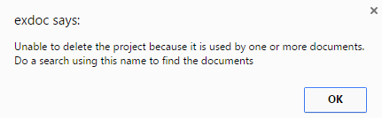

Administration/External Parties
Here you can add External Parties. These are persons or organisations that are not users in the ExDoc, but have a close involvement with the contract, e.g. a legal firm or agent. They might also be interested to receive e-mail reminders from ExDoc.
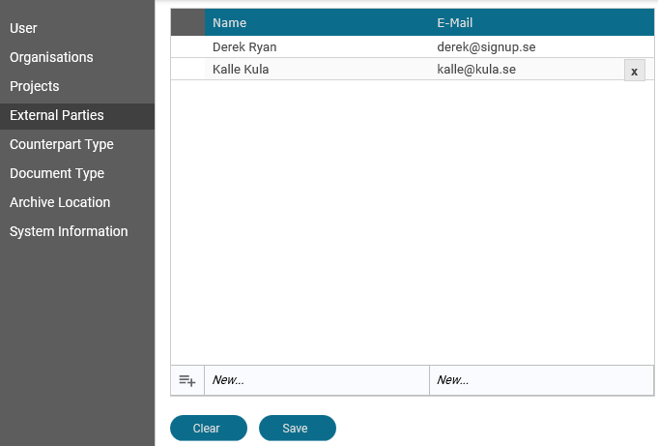

To add a party, enter the name and e-mail address and click the ‘Add New’ button. To change an entry, select it first in the list. It will appear in the edit boxes. Click ‘Save’ when you have completed your changes. Note: any changes you make will show on all documents that use this name.
ExDoc will not let you ‘Delete’ a party if it is associated with any documents or reminders.

It is not mandatory to use this option and the tab can be hidden if preferred.

Administration/Counterpart Types
A Counterpart Type in ExDoc is used as a simple category to apply to all documents when they are registered and can be used to filter on in the result grids of ‘My Documents’ and ‘Search’. An example might be to distinguish between external agreements and those that are inter-company within a group, so the types would be ‘External’ & ‘Internal’. Or you could use more categories as in the example below:
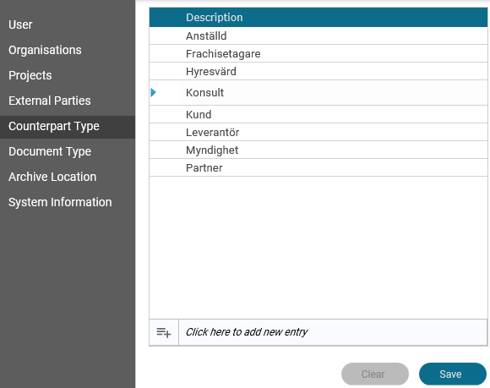

To add a new Counterpart Type, click in the ‘new entry’ text box and enter your new value. Press ‘Tab’ to add your new entry to the list. Click the ‘Save’ button if you are happy with the new type. To change an entry, click on it first in the list. Then you will able to edit it. Press ‘Tab’ then click ‘Save’ when you have completed your changes. Note: any changes you make will show on all documents that use this name.
ExDoc will not let you ‘Delete’ a type if it is associated with any documents.
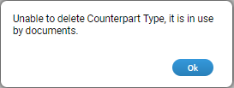

Administration/Document Types
Every Document stored in Exdoc must be assigned a Document Type. Most of these will have been determined during the initial workshop and configured at installation. However you can use this panel to ammend or add new types. In particular, note that you can add extra data fields for each different document type.
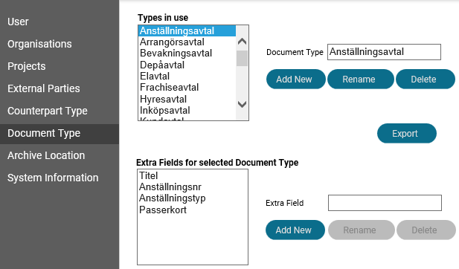

Add New | You can click directly in Document Type text box and enter your new name. Click ‘Add New’ to save it to the list.
Rename | Click on the name in the list first. It will then display in the text box. Change the name and then click ‘Rename’ to save back to the list.
Delete | Click on the name in the list first. It will then display in the text box. Click ‘Delete’ if you are sure you do not need this type. ExDoc will not let you delete a type that has been assigned to documents even if they are inactive.
Add New Extra Field | Click on the document type in the list to see the extra fields for that type. If you need another field, enter it in the ‘Extra Field’ and click ‘Add New’
Rename Extra Field | Click on the extra field name in the list to see it in the edit box. Cahnge the name and then click ‘Rename’
Delete Extra Field | Click on the extra field name in the list to see it in the edit box. Click ‘Delete’ and then OK in the message to confirm.  Note: ExDoc will NOT stop you from deleting an extra field that is being used. Data could be permanently lost.
Up/Down | Select an extra field name and click the ‘Up’ or ‘Down’ button if you want to change the order that the fields are displayed.

Tip: Click the ’Export’ button to create a spreadsheet list of all the Document Types.

Administration/Archive Location
This is the tab for a simple drop-down list of values. In the default configuration it is called Archive Location. However, depending on your organisations requirements, it could be used for any ‘flat’ dimension which is a list of pre-defined values. It is not mandatory can be hidden if preferred.
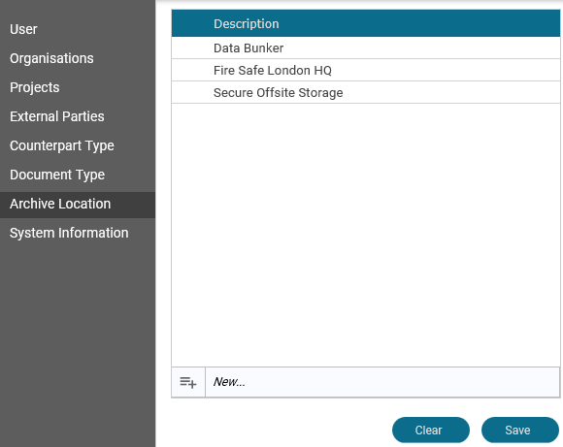

New… | Click in the ‘New…’ text box and enter your new Archive Location  then press TAB to add it to the list.  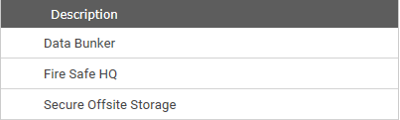  Finally click ‘Save’ to write it to the database.
Rename | Click the name in the list first. You will then to change the name.  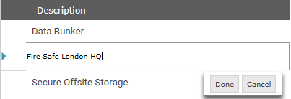  Then click ‘Done’ to save to the list. Click ‘Save’ when finished.
Delete | Hover on the name in the list. It will then display an ‘X’.  Click the ‘X’ if you are sure you do not need this value. ExDoc will not let you delete a value that has been assigned to documents. Find the documents in ‘Search’ and edit to change to a new value.

Administration/System Information
In this panel you can see the system settings for ExDoc. Except for adding more path values you cannot change any of these. 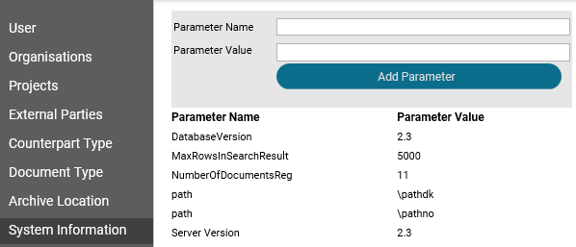

Database Version | Specifies the release version of the ExDoc database. Can reflect changes in tabes and stored procedures. Include this information when you send in a support request.
MaxRowsInSearchResult | This parameter limits the number of rows returned from a search request. Stops a ‘blank’ search from flooding the browser.  If you think you need a higher number hear, e.g. you want to return rows for all documents so that you can do a full report then contact your system administrator.
NumberOfDocumentsReg | This shows the total number of documents registered in ExDoc including inactive. Here you can see if you are getting near to exceeding your licence limit.  It will also help you to see if the previous parameter might need to be changed.
Server Version | Specifies the release version of the ExDoc web application. Can reflect changes in scripts as well as binary executables. Include this information when you send in a support request.
path | This parameter is referred to in “  Scanning Documents & Scan path” and “Administration/Users/Path”. An initial ExDoc configuration has one example ‘hr’ representing a private folder for the Human Resources department, who typically need to keep new employee contracts confidential even from other ExDoc users. More paths can be added as required. You must define your a private paths here before applying them to users.  Enter ‘path’ in ‘Parameter Name’ and the sub-folder name in ‘Parameter Value’ and click ‘Add Parameter’. You can add as many different ‘path’ parameters as you need for each user(s).  !  Note: in ‘path’ you must use lowercase ‘p’; otherwise you will be blocked from saving.  Next, create a sub-folder with the same name under the ‘ScannedImages’ share on the file server.

ExDoc Reminder Sender
This is installed as part of the ExDoc system. It can run on the same server machine as the web application or on the databse server, and is added to the Task Scheduler. It does the job each day of looking through the database for reminders that should be sent out to the correct ExDoc user or external party. It formats the email message and sends it to the company mail server.

!
Note: It is not administered with the Administration functions in ExDoc.

Here is a list of parameter keys that will have been set-up at installation time but are good to know about if you want to change any of the settings afterwards. Your System Administrator will have an “ExDoc Delivery Document” which has the details of where to find this configuration file.

Job Name: | “Reminder Sender for ExDoc"
key="Cc" | You can have an email address here so that every reminder e-mail that is sent by Reminder Sender will also be copied to this person who could be the main responsible person for agreements. This can be useful as a double check that emails are being sent and that someone is responsible.
key="Bcc" | Same as above except that the main receipient will not see who has a copy.
key="DefaultReminderText  ExternalParty" | This is the text in the message that is sent to an external contact:  "This is an automatic reminder generated by ExDoc Reminder Service regarding the document mentioned below. CUSTOMER has added you as someone that should be reminded about this document today. Please contact CUSTOMER for more information."  If required, this can easily be changed.
key="DefaultReminderTextUser" | This the text that is sent to an internal ExDoc user. They will also get a direct URL link to the document.  "This is an automatic reminder generated by ExDoc Reminder Service regarding the document below."  This can also be changed.
key="UserDefaultText" | "Please log on to ExDoc to view all information regarding this document: "
key="ExDocURL" | If the ExDoc application is ever moved, remember to change it here as well or the link will no longer work.
key="UseExtendedLogging" | By default, the sender logs detailed information to the windows event log. Once everything is working well, the amount of logged can be set to low.
network host= | This is the ‘SMTP’ mail server. Update the value here if this is changed in your organisation.  !  Note: The SMTP server must allow anonymous relaying from the server where this job runs.

Application Options
There are some application options that are controlled by parameters in the web applications config file. This file is called ‘web.config’ and can be found in the root of web application folder.
Most of these options will be set-up at installation time. How they will be set should be discussed and determined during the ExDoc workshop. However, it is also possible to change any of these options at a later time.

deletefileafterreg | Normally set to true which means that the scanned file that was placed in the ScannedImages folder is deleted after registration.  If set to false, the file will be moved to a sub-folder called RegisteredImages. This means that you will have a copy of the file on the server as well in the database. However this could be a security access risk.
Language | Can be either en-GB for English or sv-SE for Swedish. This setting determins the default choice with Form login and is the only choice with Windows login.
DocumentReminder | When set to true, ExDoc will automatically create a reminder for all Document Owners. Requires that a due date is entered.
AutoReminderLeadTime | This is the number of months before the due date that the reminder will be sent. This will be the same for all auto-reminders.
ShowExternalParties | Set this to false if you do not use the external parties function and want to hide all references to it.
BlockNonIEBrowser | This is normally set to true becase ExDoc is designed to work with Internet Explorer. For organisations that will have users that are only going to be viewers, you can allow use of other browsers, e.g. like Safari on Macs, you can set this to false.
UseFrameAgreements | New check box field. The standard name refers to frame agreements. Hide by setting to false.
UseFreeDimensionMultiSelect | There is a flat dimension usually called project. The default is false, only allowing a single value to be assigned. When set to true, multiple values can be selected for a document.
SearchShowAllDims | Set to true if on the search page you want to hide organistions and projects that the current users has not been granted access to.
ShowDropDownList1 | Set to true if you want to use archive location. See above for more details.
AutoDeactivateDocs | This will add a check box to register and edit. An end must be entered. When the end date has passed, the reminder sender task will change the status of the document from active to inactive.
Field1……10 | Optional extra fields. These can be named as needed.

