

ExDoc 3.0
User Guide for Web Contract Management

Last revision: 2017-11-28

Contents
Introduction 4
Concepts 5

User Role 6

Reminder Service 6

External parties 6
Logging in 7
Registering Documents 9

Choose Scanned Files 9

Header Data 11
Confidentiality Level 11
Document Type 11
Document Title 12
Counterpart Type 12
Counterpart Name 12
Counterpart ID 12
Agreement No. 12
Organisation 13
Project 13
Archive Location 13
Frame Agreement 13
Fine Clause 13

About Document Dates 14
Document Date 14
Start Date 14
Due Date 14
End Date 14
Date Cancelled 14

About Reminders 14
Manual Reminders 14
Automatic Reminders 14

Document Dates and Reminders 15
Active 16
The Date Chooser 16
Automatic Extension 16
Auto deactivate 17
Adding a Reminder Manually 17
Make the Reminder Recurring 17

Owners and External Parties 18
Adding and Removing a Document Owner 18
Creating an External Party. 19
Associating an External Party with a Document. 19

Descriptions, Links and Attachments 20
Description 20
Considerations 20
Miscellaneous 20
Journal 21
Document Links 21
External Files 21
Registered Documents 21

Completing Registration 22
Missing Mandatory Fields 22
Edit Documents 23

Differences in Edit Panel 24
My Documents 25

Document Data Details 27
Search 28

Exporting a report 30

About setting search criteria Error! Bookmark not defined.
My Settings 31
Events 32

Introduction
The administration of original agreements can become a time consuming chore for any organisation. When you start with a small number of agreements things are simple, but as the number of agreements increase, you will start to wish that there was a better way to do this.
ExDoc, a web based software application that stores everything in a popular database, is a tool for controlling paper contracts with signatures and other kinds of agreements. By scanning the original agreement, you get an electronic copy that can be stored securely together with additional relevant information, and managed by ExDoc for the lifespan of the agreement.
As the agreement goes through different stages, ExDoc can update you via e-mail, reminding you to take the appropriate action at each time.
Contracts and agreements are always of a confidential nature, so a comprehensive security system is built into ExDoc, securing the information from unauthorized access. Furthermore, ExDoc includes an advanced audit trail system that monitors how, when and by whom a specific document is accessed.
This guide will explain the basic concepts and how to use ExDoc.

Concepts
Moving from manual handling of agreements to ExDoc involves a few important steps. If the agreement is on paper, it must first be made ‘electronic’ by scanning. The scan will result in a file such as Tagged-Image File Format (TIFF or TIF) or preferably an Adobe Reader Portable Document Format file (PDF). The original source document can also be a non-paper document such as a Word document, Excel worksheet, or a program originated PDF file with digital signatures. Once in electronic form, we can start to work in ExDoc.
The first step is to register the electronic document in ExDoc. As well as loading the image into the database, this involves associating relevant information with the document. This type of information is generally referred to as ‘meta-data’. What type of data this should be, can be answered by asking what do I really need to know about this agreement, to be able to manage it efficiently? Is the agreement signed with an external party or is the counterpart internal to the company or group? What type of agreement is it? Is it a rental contractor an employee agreement? Which organisation in the company is the agreement linked to? And perhaps, most importantly, when is the agreement due to be renegotiated?
In this way, all the data you need, will be stored together with the document ready to be accessed, searched and edited using a standard Internet browser.
One of the key features of ExDoc is that a reminder e-mail can be automatically sent to the documents owner, 1 or 2 months before the due date. For most agreements, once the document is properly registered, you can ‘leave it be’ until the reminder alerts you to take action.
Does this mean that we can now tear up all the paper agreements once they are registered in ExDoc? Probably not, but it does mean that you can store them in a safe place off-site.
Putting ExDoc into effect has an initial period, where the many existing contracts and agreements are scanned and registered. After this you will use ExDoc by adding new agreements, act upon reminder messages and inactivate expired agreements.
In ExDoc and in this manual, contracts and agreements are referred to as ‘documents’. Any important information can be saved as a document in ExDoc, for example company incorporation papers.
You do not delete documents from ExDoc; instead you set the document ‘Status’ to inactive. Then you can still refer to them later.
Before you start working with ExDoc, you should familiarise yourself with the general concepts of an agreement management system and also the specific ways in which ExDoc works.

User Role
Each ExDoc users is assigned one of these roles. These are designed to limit access to the functional parts of ExDoc. The roles are:
Viewer | The user is limited to viewing documents.
User | A user, with the ability to register and edit documents.
SuperUser | Same as ‘User’, but with the added ability to view Events.
Admin | This user cannot view any documents. This role is for adding users and changing other system parameters.

!
Note:
- A user can be given different combinations of roles. For example, the role SuperUser is often combined with the role Admin. This gives access to all parts of ExDoc.
- The roles that can actually register documents are User and SuperUser.

Reminder Service
When a document is registered, an e-mail can be scheduled to be sent to any ExDoc user with a valid e-mail address. The purpose of this mail is to remind the responsible user of upcoming events such as the need to renegotiate the contract in good time.
Generating a reminder also gives you the opportunity to add a note giving information to clarify what needs to be done. For example ‘Call Mr X at +46-8-1234567 to discuss a possible prolongation of the …’

External parties
When an agreement is made there is often a ‘third party’ involved, for example a law firm or a contractor. ExDoc gives you the possibility to register external parties and associate them with specific documents. You can also use the reminder service to send e-mails to these parties as well, even though they are not ExDoc users.

Logging in
To use ExDoc you need a Windows PC with Microsoft Internet Explorer (IE) version 11.0, Microsoft Edge, latest version or Chrome, latest version. You should also have been given the ExDoc URL and an account to use.
The URL could look something like http://intranet/exdoc. Open Internet Explorer and type in the ExDoc URL in the address field. After pressing Enter you will see the logon screen of ExDoc:
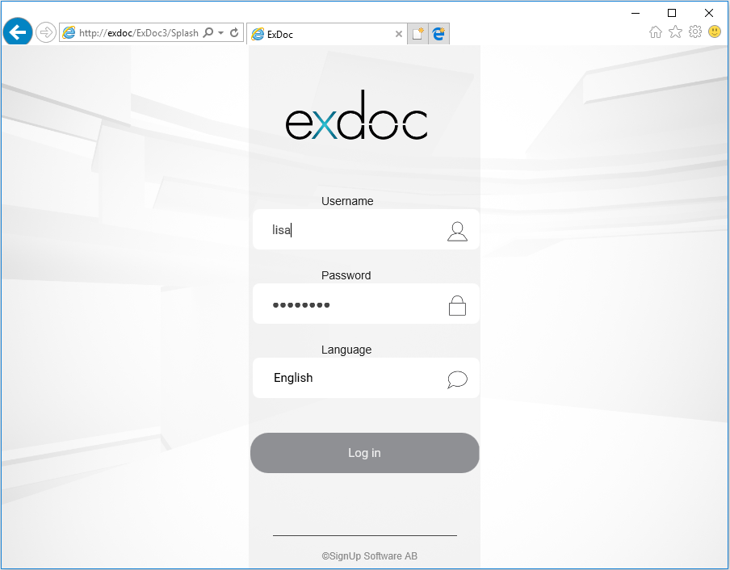

Now you can type in your Username and Password and click the ‘Log in’ button. Your initial password will be “password” (without the quotes) at first login. You should change this to a personal password in ExDoc. You can see how to do this under
My Settings. In the screen above, Lisa Doksson logs in with her username ‘lisa’ and fills in her password. The password is not shown in clear text, but as a string of asterisks.
If your system has been configured to use integrated windows login you will either go directly to the first page or see an option where you can change language.
After logging in you will see the ExDoc page. The tasks you can perform in ExDoc are found under the different tabs: Register, Edit, Search and so on. Which tabs you see here is dependent on what type of User Role is associated with your account. After logging in to ExDoc, the focus is set to the ‘My Documents’ tab if you are an owner of any documents, otherwise you will start at the Search page.
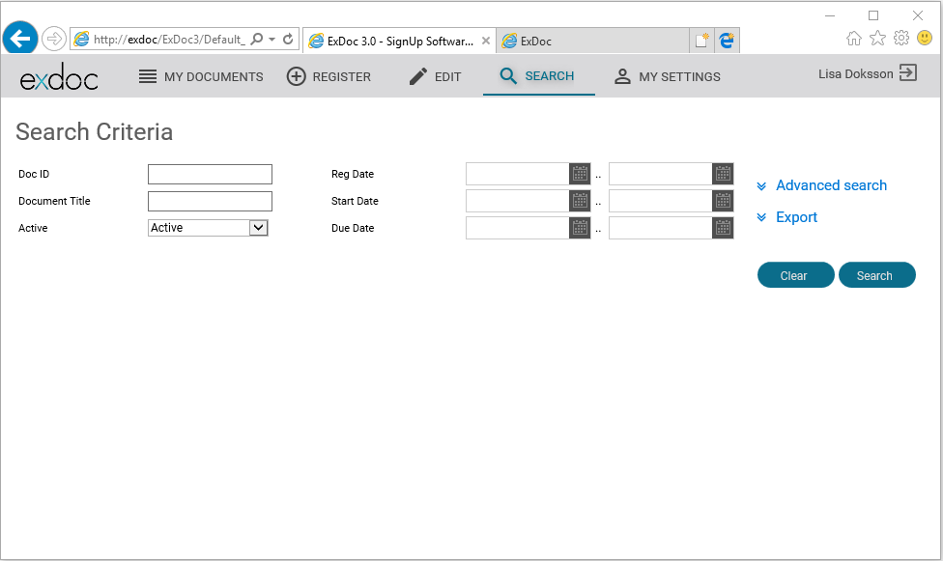

In the screen above we can see that the user ‘lisa’ has logged in but there are no documents registered with ‘lisa’ set as Document Owner so it shows the Search page.
In fact, the only documents you will ever see in My Documents are the ones where your account has been set as owner, hence ‘My Documents’ (more later).Lisa has the User Role ‘User’ meaning that she can register documents, change documents and search for documents in the ExDoc database. If Lisa had the role ‘Viewer’, the Tabs Register and Edit would not have been shown.

Registering Documents
The first step to use ExDoc is to add documents to the database. You do this by clicking on the Register tab.

Choose Scanned Files
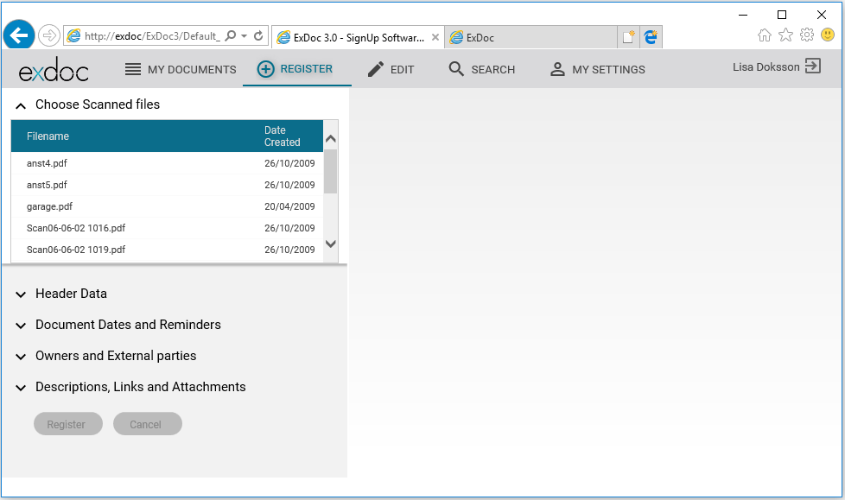

Here you can see the Register page. On the top-left hand side is the header Choose Scanned files.
Each line in the Choose Scanned Files Section, represents a scanned document. Typically, the default filename generated by your scanner (Scan06-06-02 10190001.PDF) does not tell you anything about the actual document. By clicking on the file name, the document image will appear in the right hand pane. The Choose panel will collapse and the Header Data panel will expand.

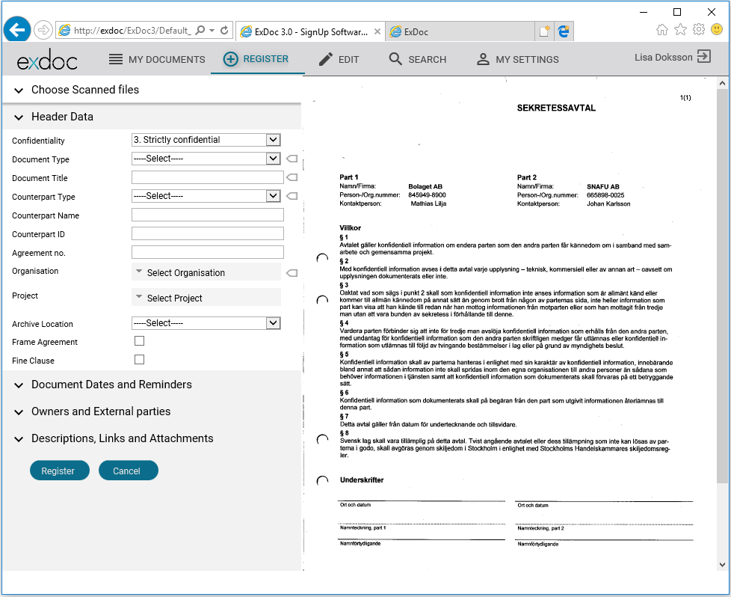

As the document in this example is a PDF-type document, Adobe Reader opens the document and displays it in the browser. Now you can use the functions in Reader to print, zoom, search and rotate the document as you wish. The same is true for any kind of document format that can be viewed in a browser.

!
Note: This is true for older versions of Excel and Word, however newer versions do not have a browser plug-in so when you click on the button beside the name of the worksheet (.xlsx) or document (.docx) the browser will ask if you want to open it or save. Choose ‘Open’ and it will automatically be opened with the correct in Microsoft application. This will show you the document but in a separate window. Enter the required data into ExDoc in the same way as normal. When you click ‘Register’, the document will be loaded into the database.
Now that you have an image of the scanned file to read, we can start to input the meta-data that we want to associate with the document.
There are several sections on the meta-data input panel. By clicking on the underlined ‘Section Name’ that panel section will expand, showing you the data fields you can input with the document. If you click on the name again, the section will collapse.
We will now go through these in detail.

Header Data
Here you can see the meta-data fields for Header Data  On the right there are some tags ‘’. This means that these fields must be entered. If one of these ‘mandatory’ fields is not filled in, you will not be able to save the document. This is to ensure that you will always be able to get valid results when doing a search in ExDoc. | 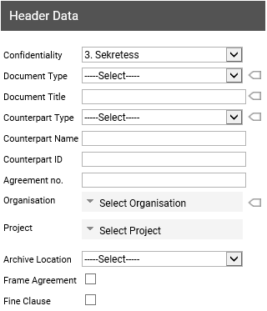
Confidentiality Level  All documents must have a confidentiality level:  1. Open  2. Confidential  3. Strictly confidential  All ExDoc users are associated with one of these levels. Access applies as:  A document with ‘Open’ can be read by ExDoc users of all levels.  A document with ‘Confidential’ can be read by users associated with the levels Confidential and Strictly Confidential, but not by users Open.  A document associated with ‘Strictly Confidential’ can only be read by users who also have the level Strictly Confidential. | A down arrow at the far right of a field means that you have a list to choose from.  Clicking the arrow, will open a dropdown list where you can choose one of the alternatives.    Click on ‘1.Open’ to disable Confidentiality on the document.  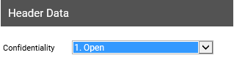  The default value is ‘3. Strictly Confidential’ ensuring that the level will not be too low, if you forget to set this field.
Document Type  Choose the document type that best represents this agreement.  The contents of this list will be created by the system administrator to suit the needs of your organisation. | Click on the down arrow on the right to see the list and click on the correct alternative.  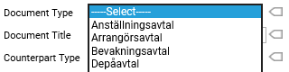
Document Title  Give the document a title which is descriptive and easy to distinguish. | This is a free text field.
Counterpart Type  Choose from the pre-defined list the Counterpart type that best represents the counterparty with whom your organisation has made this agreement. | Click on the down arrow to the right, choose from the list and click on the chosen alternative.  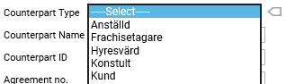
Counterpart Name  The exact legal name of the counterparty in the agreement. | This is a free text field.
Counterpart ID  This is the unique ID number associated with the counterparty, e.g. company registration number or employee number. | This is a free text field.
Agreement No.  Many contracts have a unique identification number or combination of digits and letters. | This is a free text field.

Organisation  The agreement is assigned to one of the organisational units within the company. This is usually the unit that should be selected here as they will be responsible for future actions.  The hierarchy displayed in this control will be created by the system administrator to suit the needs of your organisation. If you feel that changes or additions are required contact the administrator. | Click the down arrow to open the dropdown control. Note the arrow symbols allow you to expand the organisation structure. Make your choice by marking the box next to the name.  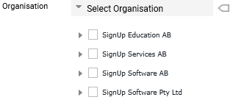  You can close the list by clicking the arrow.
Project  Many agreements are for a particular requirement. This field is especially useful if there are many agreements for this need.  This list can easily be added to by the system administrator.  !  Note: This list could have a different name and function in your organisation. | Click on the down arrow on the right to see the list and then click on your choice.  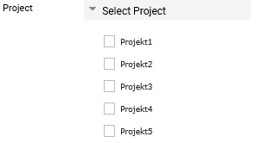
Archive Location  This is a list of the physical storage locations for the original paper agreement.  !  Note: This drop down list could have a different name and function in your organisation. | Click the down arrow to see the list and then click on your choice.  
Frame Agreement | Check the box if you need to ‘tag’ a document as a Frame Agreement.
Fine Clause | Check the box if you need to ‘tag’ a document as being subject to a penalisation clause.

About Document Dates
ExDoc uses four dates to describe the lifespan of an agreement. It is important that all ExDoc users are aware of the exact meaning of these dates.

Document Date
After agreeing terms, the parties both sign. This date is the Document Date.
In ExDoc this date is always required. Your installation could have a setting that makes the other dates mandatory as well.

Start Date
The agreement stipulates a date when the terms are valid. This gives us a Start Date.

Due Date
The agreement could stipulate a date for renegotiation. Very commonly, the agreement defines a period of time before the end date e.g. 3 months, when if formal notice has not previously been given, then it will automatically be extended for a further term. The end date minus this period will be the Due Date i.e. the last date notice can be given. Reminders should be set to give an alert with sufficient time before this date.

End Date
The absolute duration of the agreement can also be stipulated, after this date the agreement is no longer in effect. This is the End Date.
For some contracts, if the due date is missed, then the agreement remains in effect. Sometimes, this might even be desired. In this case you can set an ‘Automatic Extension’ period. After the due date has passed, ExDoc will update the Due and End Dates.

Date Cancelled
This should be the date that cancellation notice was sent to the counterparty.

About Reminders
One of the most useful features of ExDoc for improving the timely management of contracts is the Reminder function. These are usually set as part of the Registration process. However, they can also be added or emended later using Edit.
ExDoc runs a job every day to find Reminders that are due, then generates and sends out e-mail messages. There are two types of e-mail template. The first, to ExDoc users includes a hyperlink directly to the correct document in the system. When you click on the link in your e-mail, a browser window or tab will open to ExDoc. After logging-in, you will be go directly to the correct document with the details displayed. Of course, the template for external parties who are outside the company does not have this hyperlink. There are two types of Reminders in ExDoc:

Manual Reminders
These are set at registration in the section Error! Reference source not found. and are described below in “Adding a Reminder Manually”. You can also set a Reminder to recur. This is mainly for use with ‘Automatic Extension’.

Automatic Reminders
This is only available if your system administrator has chosen to use the ExDoc Automatic Reminders function. He will also define a lead time e.g. 1 or more months which is calculated as being before the due date. If so, it will apply to all ‘Active’ documents where a Due Date has been set and a Document Owner has been assigned.
After a document is registered, ExDoc will automatically generate a reminder to be sent 1 month before the Due Date for all users that are in the ‘Owner(s)’ list, see “Adding and Removing a Document Owner“. You will see these reminders when you select the document row and display the Document Data. If you later Edit the document and add another user to the list of Owners, then that user will also get a reminder.
Note: If you enter a ‘Due Date’ that is less than the lead time in the future, i.e. the reminder date would be before today then an auto reminder is not created.

!

Document Dates and Reminders
In this section you can:  - Check the ‘Status’ of the document.  - Set the four main dates for the document.  - Make an agreement automatically extend.  - Set a document to be made inactive after the end date.  - Set ExDoc to generate e-mail Reminders for ExDoc users and/or External Parties.  - Add a useful text message. As standard, the e-mail will already include these fields Document ID, Document Title, Counterpart Name, Due Date so the message can be more about what needs to be done.  - Set a Reminder to be Recurring. | 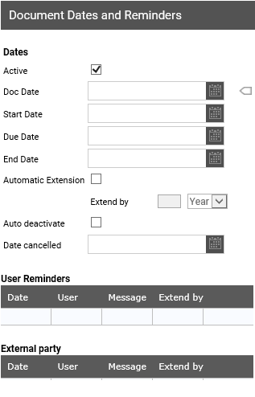

Active  At registration this checkbox is always set to active. However if you are registering an old agreement for reference purposes, you should uncheck this. | Once the agreement has passed its End Date the document should be set to inactive by removing the checkmark from the box.  Tip: See also Auto deactivate below.
The Date Chooser  Normally you find the dates somewhere in the original document image on the right-hand of the screen.  Do this for all date fields that are needed.  Tip: You can click ‘Today:’ at the bottom of the box to choose today’s date. | Click the down arrow to open the date chooser. First select year, then month and finally day.  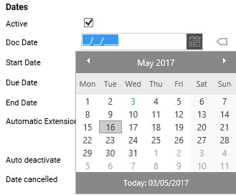
Automatic Extension  You can mark that you want the Due Date and the End Date to be updated by the number of periods selected.  This will be done automatically when the Due Date has passed and the document has not been Edited to remove this check and made ‘Inactive’.  Setting this will show that the terms of the agreement say it will be automatically extended if it has not been cancelled before the due date.  Sometimes, extension of the agreement is expected, so this will make the dates correct for the new period. | Click on the checkbox first, then enter a number and a choose a period.  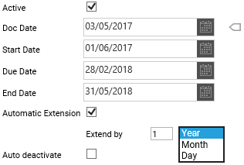  !  Note: You must enter valid dates for Due and End Date for them to be updated correctly.

Auto deactivate  Check this box if you want ExDoc to mark the agreement as inactive after the end date.  Do not do this unless you have sent the correct cancellation notice before the due date. Record the date it was sent in ‘Date Cancelled’  Typically, the agreement remains in force untill the end date. This function will save you having to edit the document on the end date to set it inactive. | 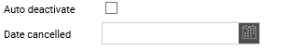  Tip: Add a copy of the cancellation notice as an attachment.  !  Note: You cannot set auto deactivate and automatic extension. It can only be one or the other or neither.
Adding a Reminder Manually  Each Reminder set is for a single user, to be sent on a specified date. If more then one person should need prompting, repeat the process after selecting their name from the list.  Sometimes, a series of actions are required on different dates. If so, repeat the process for each date with a useful description of the action in the message.  You can also send e-mail reminders to non-ExDoc users, who can be internal or external to the company. | Select a User from the dropdown list. Then chose a date. Finally, add a descriptive message.  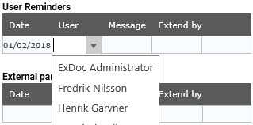
Make the Reminder Recurring  This is most often used together with ‘Automatic Extension’. If you have set this on, then when you make the reminder, and set the reminder date to a suitable time before the due date, then also set the reminder to recurring. That way, if you decide to ignore the first reminder because you want the agreement to run on for a further period, ExDoc will update the reminder so that it is sent again before the the new due date. | Click on the checkbox first, then enter a number and a choose a period.  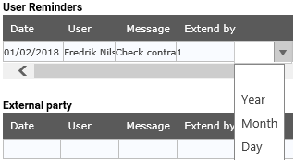

Owners and External Parties
Here you can do three things:  - Assign owners to the document.  - Associate one or more External Parties with this document.  - If the External party is not in the list, you can create it here. Give them a name and e-mail address. Then you can associate them with this document and any documents in the future. | 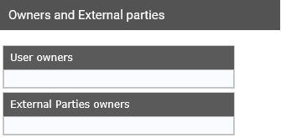
Adding and Removing a Document Owner  Here we add an ExDoc user as a Document Owner.  The Document Owner is the person or persons that are most closely related to the agreement. When you assign a user as the owner it will ensure that this document appears in their My Documents tab which is the first page they see when they open ExDoc.  Typically, they are also the person or persons that should receive reminders pending the document due date. If Auto-Reminders has been set, then they will automatically get a reminder at least one month before the due date. | Open the dropdown list and mark a user name.  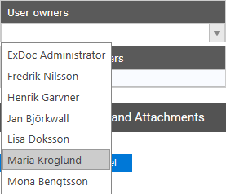  Then press the TAB key.  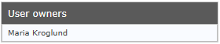  To add more users as Document Owners, select a new user and press TAB again.  If you would like to remove a user, hover over the name and click the X.  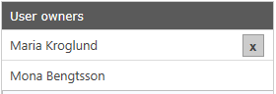

Creating an External Party.  An External Party is not a user in ExDoc but still might be closely related to the agreement.  For example, the External Party might be Sarah Wilson, a lawyer responsible for drawing up a number of contracts with different customers.  Tip: Add the company name after the personal name. | If the external user/party we want to associate does not exist already, we first have to create the party.  Click the Radio Button at Create New External Party.  Fill in the name and e-mail address for your party, and then click the Create button.  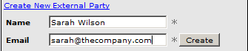  Now Sarah will show up as a selectable external party.  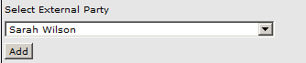
Associating an External Party with a Document.  Once the External Party is created, you can associate it with a document. | Open the dropdown list and mark an External Party name, then press the TAB key.  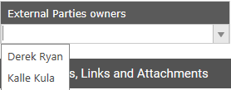  The external party has now been added to the document. Repeat this procedure to add more External Parties to the document.  To remove an external party, hover over the name and click the X.

Descriptions, Links and Attachments
Here you can:  - Enter free text describing the agreement.  - Add Journal entries which automatically add the User name and date.  - Save additional files in ExDoc such as price lists in a spreadsheet, product or project descriptions in word documents.  - Add links to other documents within the ExDoc database. | 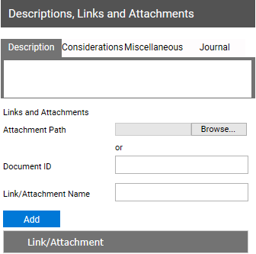
Description  An optional field for a short description of the contents or purpose of the agreement. | 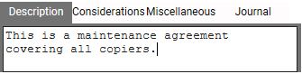
Considerations  An optional field for any important considerations or circumstances regarding the agreement. | 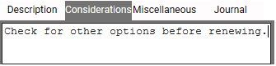
Miscellaneous  An optional field for general notes or loosely related information. | 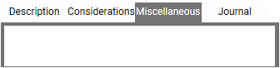

Journal  Text entered in this field will automatically have the date and user name added.  In later Edits, Users cannot delete or overwrite the previous entries. They can only add information in a new journal.  You can use this to track actions taken during the lifespan of the agreement. | Enter your activity:  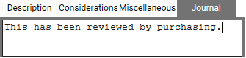  After saving it will appear like this:  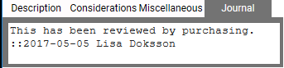
Document Links  There are 2 types of Links you can add:  - External files.  - Registered documents.  External Files  For each agreement registered in ExDoc there can be other related information. Most often these are electronic files, stored in different places. Files can be all common types such as .xls, .pdf, .doc.  In this section, you can load these files into the database. Exdoc will then maintain a ‘Link’ in the meta-data to the storage location within the system. Once added here you will not have to worry about the source files.  Registered Documents  Adding a link to another document in the system is very useful when, for example, a new replacement contract is signed. You can add a link to the previous one for ease of reference.  Or when there is a master contract and you register new addendums, add a link to the master’ ID for each one and in the master add links for each addendum. | Click the Browse button to navigate to a file. After selecting the path and file it will show up in the Attachment Path field.  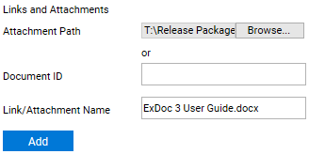  Click on Add and you will see it in the Link list.  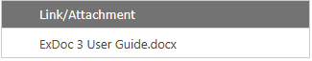  Enter the correct Document ID and a helpful description for the Link Name.  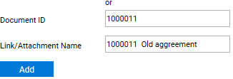  Click on Add to see in the Link list.  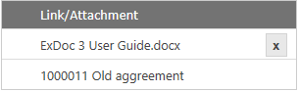

Completing Registration
Having filled in all the necessary data fields, you are now ready to save both the document image and the meta-data information into the ExDoc database.  At the bottom of the meta-data pane you will find the Register button.  When you are ready to save your information, click ‘Register’.  Note: Do not worry if you have forgotten something, in ExDoc, it is easy to add more information or make changes using the Edit function; see next page.  Only click ‘Cancel’ if you want to abandon the registration and lose the data entered. | 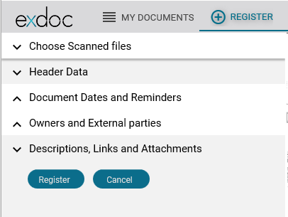
Missing Mandatory Fields  If you try to register an agreement without having filled in all the mandatory fields, those marked with tags (), you will be prompted to do so.  The fields you have missed will be listed in red below and also marked with a red tag.  For example, every document must be assigned to an Organisation. If you forget to set this, ExDoc will remind you as in the example.  Correct the error and click Register again. | 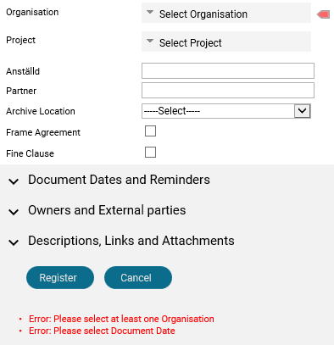

Edit Documents
Once you have registered one or more documents, eventually you will need to add more information or make some changes. In ExDoc this is done using the Edit function.
There are three different ways to access Edit. Once you are in Edit, most things work in the same way as in Register with only a few differences that are described below.

The most obvious way to find this function is under the Edit tab:
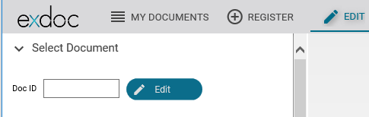

However, as you can see above, you will need to enter the Document ID of the document you want to change. In the ExDoc system, each document is given a number at registration starting at 1000000 (one million). This Document ID is the unique identifier of each document in the system.
If you know the specific Document ID, click the Edit tab, fill it in and then click Edit.

Off-course, it will eventually become harder to keep track of all the Document IDs so you can use the other easy way to edit a document.

This is available under the Search or My Documents Tab.
When you have a list of documents, in the left column you will see a pencil icon .
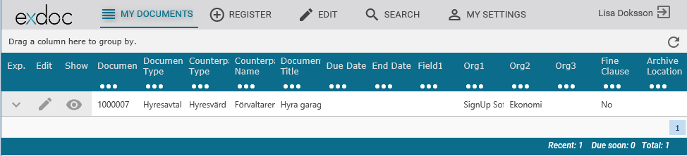
Click the pencil next to the row for the document you want to edit; it will then open up the document in the Edit tab.

Differences in Edit Panel
There are a few differences from Registration when you Edit the documents’ meta-data.  - You will not see the ‘Choose Scanned Files’ section as you can only work on the data for the document you have choosen to edit.  - Under Reminders, in the list, you will see all reminders including any old reminders where the date has passed.  - Also, when you hover over the reminder you will see a ‘X’. You can click on it to delete the reminder.  - Under Descriptions and Links, you cannot place the cursor in the Journal text box. This is because earlier journal entries cannot be changed. Instead click in the ‘New Journal Text’ box and write a new entry.  For all other actions, refer back to the Register section. | 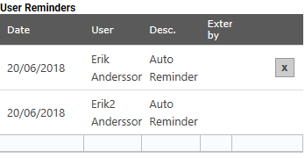  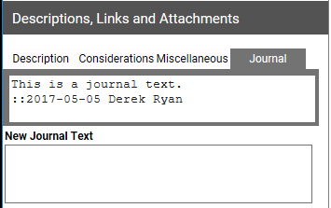

My Documents
My Documents is the first page shown after a user logs in. As the name suggests, only documents where the user is set as Document Owner are listed. In addition, only ‘Active’ documents are included. Most often, this user is the person responsible for these agreements.
If the document has more than one Owner assigned, then they will also see this document in their respective ExDoc under My Documents. If the user is not set as owner for any Documents, he will start in the Search page.
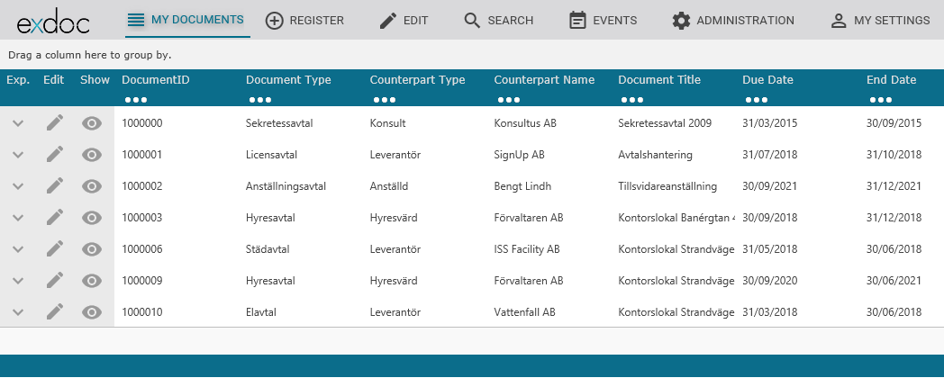

The total number of documents is shown on the far right.
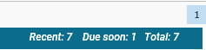

The column headings can be used to sort the results, for example on Document Title:
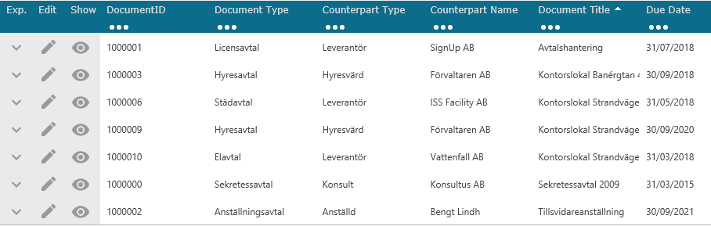

Click on the “…” in the column heading to apply a filter:
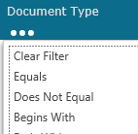 e.g. select “Equals” and type in a value and press enter 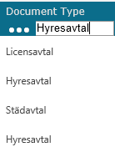 will give:-
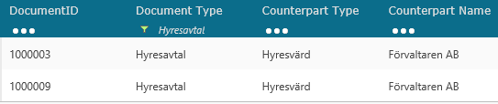
Alternatively, selecting “Does Not Equal” will give:-
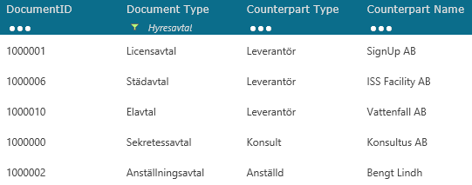

To filter Dates use “Contains” e.g. ‘2018’ will give:-
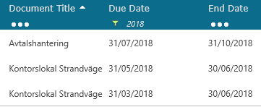

Document Data Details
Clicking on the icon on the in the left column will open the document in the Edit page. You will be able to see the image and all of the meta-data that way, but if you do not need to make changes, a quicker way is to click on the Expand icon so that the Documents Data details panel expands below the row. Here you will see all the documents associated information.
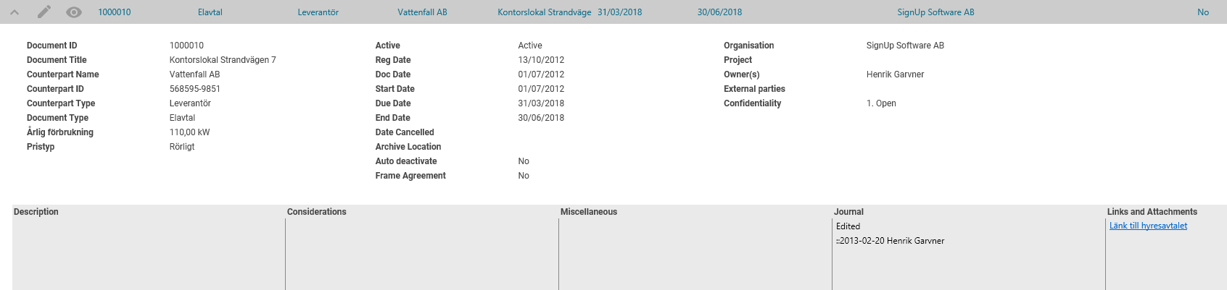
Notice the Eye icon, click on this and the document image will open in a new window. This is the original scanned image of the agreement.

Search
When you have registered many documents and you need to retrieve one or a set of similar contracts, you can search by clicking on the Search tab:
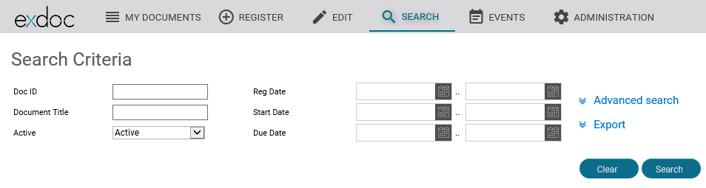

If you click the Search button without selecting any Search Criteria, you will retrieve all the documents that you are authorised to access. The system default will limit the results to 5000 documents. Contact your system administrator if you think you need to increase this. One reason you might want to do this, when you know that you have uploaded more than 5000 documents into the system and you would like to make a report of all the document data.
More normally, you will want to limit the result set to those that are most relevant. To do that, enter one or more criteria. E.g. if you put in the ExDoc unique document Doc ID it will return the info for a single document. Alternatively, put in a word in Document Title that you know is in the agreement title. It will return all documents that have the word in the title.
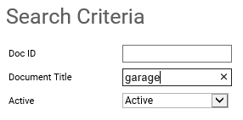
Note the ‘Active’ criteria. If you want to include old expired agreements as well, use the drop down to show “All”. When you click ‘Search’ you will get a limited number of rows.
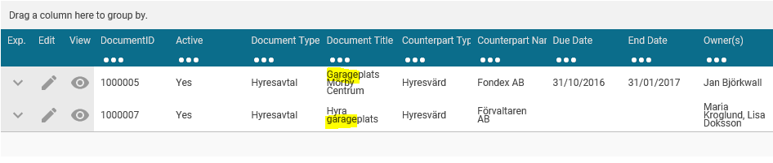

If the criteria you want to is not shown, click on ‘Advanced search’. Then you will see more options.
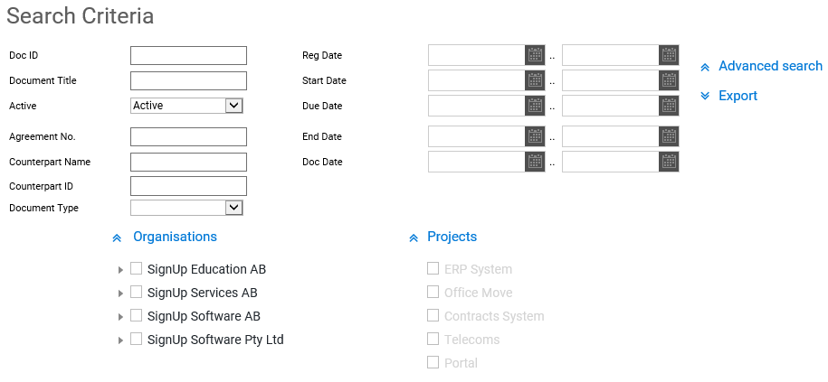
If you want to include documents for only a single organisation or area, expand ‘Organisations’ or ‘Projects’ to see those options.

Note: You can only check against one organisation and ONLY documents for that organisation will be returned, i.e. documents in sub-organisations of the one selected will not be included.

The results of the search are shown in a grid that includes columns for the most useful data for a document. The grid can be used in the same way as for ‘My Documents’ described above.
Clicking the on a row will expand that row and display all of the document data.
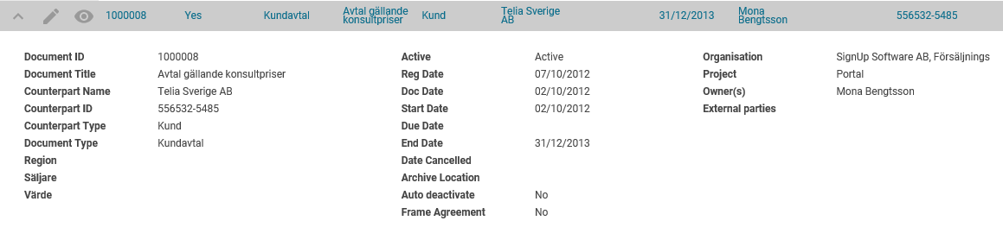
Tip: The columns shown in the grid are set by your system configuration. The selection must be the same for all users of ExDoc. However, this general setting can be changed, e.g. to remove columns that you do not need to see or add columns you find more useful, e.g. additional dates like ‘End Date’. Contact your system administrator for more information.

Exporting a report
After searching and getting the result rows that you want, you can create a report by exporting the date to an Excel spreadsheet.
If you click on ‘Export’ the options will be displayed.
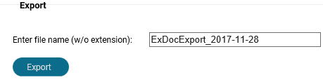
ExDoc will send all the information about the documents, including details that cannot be seen on the rows to an Excel spreadsheet. This can be very useful when checking for missing information, accuracy and consistency of naming.
It can also be used to create a report for management and other colleagues who are not users of ExDoc.

!
Note: When ExDoc has created the spreadsheet the browser will prompt you if you want to save the file or open it directly. You can choose either. When you open the file with Excel 2010 or higher, it will display a warning message that the file format and the extension do not match. However, the file is not corrupted, it is created in an XML format. Click on ‘Yes’ you want to open anyway. Excel automatically converts the xml to native format.

Tips for formatting the report:
In the standard output, some of the cells can contain a lot of text, e.g. Description. This will cause the height of the rows to be different. To make the display consistent, click on the marker in the top left hand corner of the sheet to select all the data. Then right mouse click on one of the row numbers. In the pop-up menu, select ‘Row height’ and set all the rows to ‘15’.
You can use all the features of Excel. For example, select and delete columns you do not need to show, re-order the columns to your own preference. Also very useful is to click on the ‘Data’ menu option and then click the ‘Filter’ icon. This will automatically add filter controls to the top of each column allowing you to change the primary sort order or display a sub-set of the report, e.g. for only one Document Type or for only one or several counterparties.

Important Option: If you filter on a single Document Type, the exported data will include columns for all of the custom ‘Extra Fields’ defined for that Document Type. This is the only way to export the information in these extra fields.

My Settings
This page is available to all users, only when your administrator has chosen to use “Forms” login where you must enter an ExDoc user name and password. In this case, when you first use ExDoc your account has the password set to ‘password’. You should change your password before you start to work with documents.
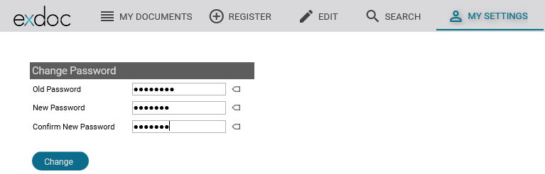
- Fill in your old password (initially set to: password)
- Fill in your new password (the password must contain at least 6 characters)
- Repeat in Confirm New Password and Click Change

If your installation is using integrated Windows login, you will not see or need this tab.

Events
Only users with the role ‘SuperUser’ will have access to this tab.
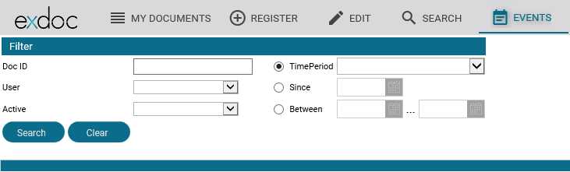

The Event function was originally developed for organizations where the information contained in ExDoc is of a very sensitive nature. All activity in ExDoc can be logged to the database for a full ‘Audit Trail’. Then in Events you can then retrieve selected activity.

In this example, we have retrieved all activity for user ‘Lisa Doksson’ for the last week. You can use the dropdowns to filter and the column headings to sort in the same way as for the other result grids.
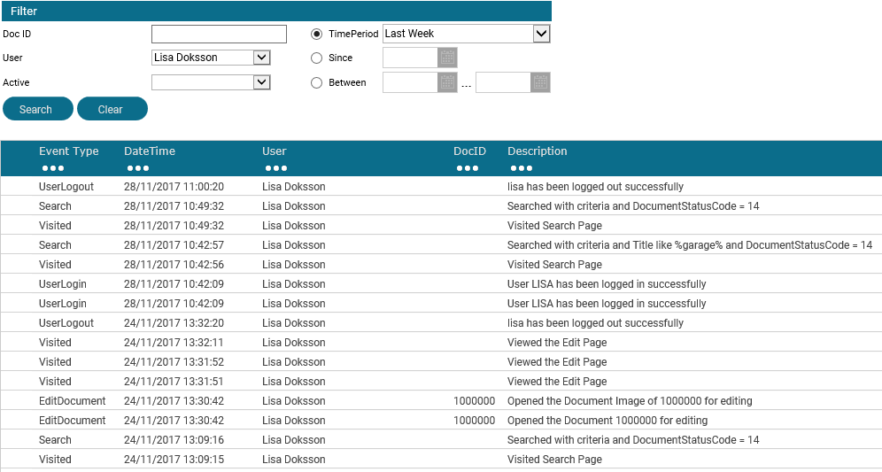

The next example shows all the a document was opened for editing in the last month.
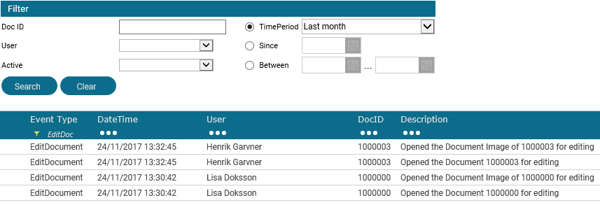
To get this report, search for Time Period of ‘Last Month’, this will retrieve all records for that period. Then use the column filter for Event Type and select ‘Begins with’ and enter “EditD”. This makes it easy to check who changed information about a contract recently.

