Exporting documents from ExDoc
Rev 2020-09-30
ExDocExtractor v. 1.0.0.0930

ExDocExtractor is a stand-alone application that is used for decrypting and saving scanned documents from the ExDoc agreement management system.
The program does not need an installation and can be run as is. Three files are included:
VbUtilities.dll
Settings.xml
ExDocExtractor.exe

To start the program, run ExDocExtractor.exe.
Settings can be adjusted either in the UI or by editing Settings.xml directly.

Database connection

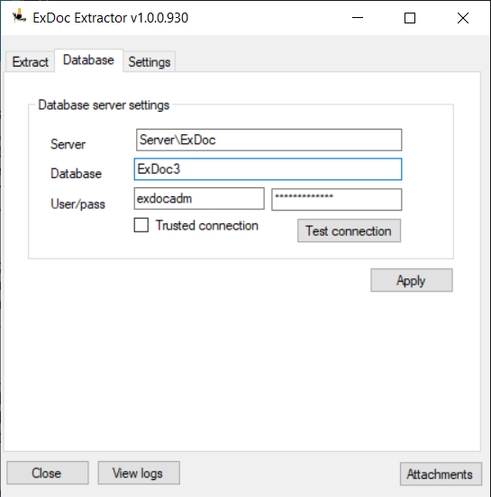

The settings for connecting to ExDoc’s database are found under the tab “Database”. If that information is not at hand, it can be found in the configuration file for ExDoc, web.config. It’s located in the root folder where ExDoc is installed on the web server. The info is found in the tag <connectionstring>.

General settings

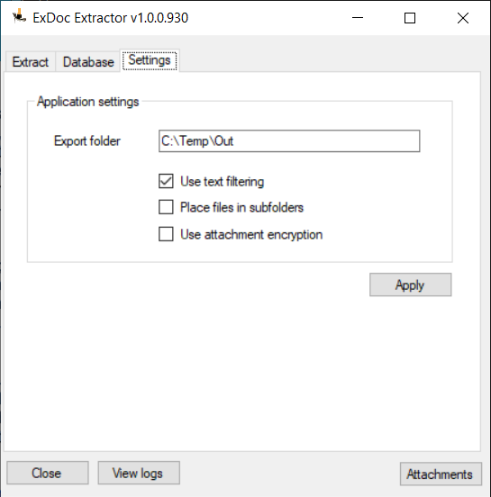
The setting “Export folder” indicates where the extracted documents are saved. Make sure the user who runs the program has read/write permissions to that folder.
The setting “Place files in subfolders” creates a folder for each company. When unchecked, all documents will be placed in the same folder.
For standard usage, leave other options at their default setting.

Extraction

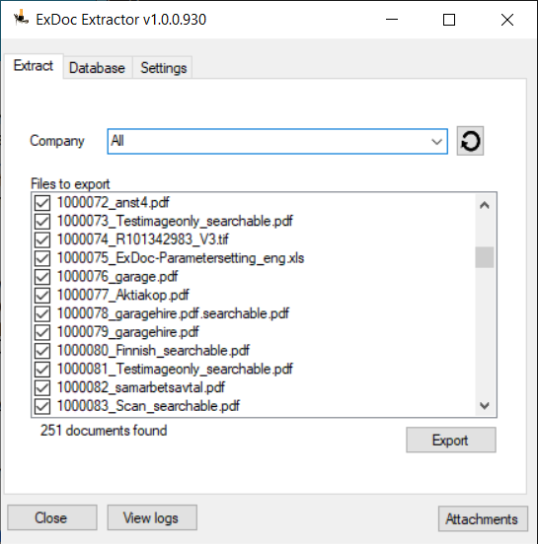

With the database connection set up, press to load the list of company names. In the dropdown list “Company”, single entries can be selected and have their documents shown in the list “Files to export”. The top choice “All” selects all companies.
To begin the extraction, click “Export”.
The document ID is included in the image filename, attachments uses doc ID plus an index number (e.g. 1000238_1.pdf).
In some cases (depending on ExDoc version) attachments might not be saved properly, getting a file size of 0. If that happens, click the button “Attachments”. This will start a raw data dump of the attachment table to file. The document ID will still be included in the file names.

Technical contact
Erik Andersson
+46 702-37 44 18
erik.andersson@signupsoftware.com

SignUp Software AB | Hallonbergsplan 5, 3tr | SE-174 52 Sundbyberg | SE
www.signupsoftware.com

